1. Write a java program that can read your name and output your name with the following

**Answer:**

package lab1;

import java.util.*;

public class Lab1 {

/**

* @param args the command line arguments

*/

public static void main(String[] args) {

Scanner scanner = new Scanner(System.in);

Random random = new Random();

int x = random.nextInt(100);

System.out.println("Enter your name: ");

String name = scanner.nextLine();

System.out.print("Your name in upper case: ");

System.out.println(name.toUpperCase());

System.out.print("Your name in lower case: ");

System.out.println(name.toLowerCase());

System.out.println("The length of your name: " + name.length() + " character ");

System.out.println("Your lucky number between (1-100): " + x );

}

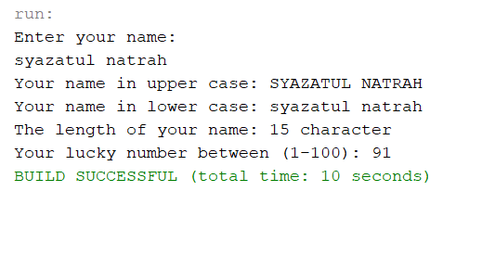

1. Identify a café in UUM and draw **3** **classes** in UML diagram with their variables. **Don’t define** any method just yet in this example. Only **classes** and **variables**.

|  |
| --- |
| **Cafe** |
| -Licence_No : String  -Type_Food : String  -Staff : String |
| -Café (String, String, String)  -getlicence_no : String  -gettype_food : String  -getstaff : String  -SetType_Food (String)  -SetStaff (String) |

1. From (question no 2) write a program to create **3** **objects** each from classes identified for the café using user input.

class Cafe {

Scanner scan = new Scanner(System.in);

private String licenceno;

private String typefood, staff;

Cafe(String licenceno, String typefood, String staff) {

this.licenceno = licenceno;

this.typefood = typefood;

this.staff = staff;

System.out.print("Enter Licence NO: ");

licenceno = scan.nextLine();

System.out.print("Enter Type of Food: ");

typefood = scan.nextLine();

System.out.print("Enter Staff: ");

staff = scan.nextLine();

}

String getLicenceNo() {

return licenceno;

}

String getTypeFood() {

return typefood;

}

String getStaff() {

return staff;

}

void setTypeFood(String typefood) {

this.typefood = typefood;

}

void setStaff(String staff) {

this.staff = staff;

System.out.println("Licence Number: " + licenceno);

System.out.println("Type of Food: " + typefood);

System.out.println("Staff: " + staff);

}

}